**CLONING OF ALGORITHM OF SELF DRIVING CAR FOR STOPING MECHANISM**

**Overview**

Cloning the algorithm of a self-driving car specifically for the stopping mechanism, it's important to note that self-driving car algorithms are complex and interconnected systems. The stopping mechanism is just one aspect of the overall control and decision-making algorithms. Cloning an algorithm for the stopping mechanism would involve replicating and adapting the relevant parts of the self-driving car's software to enable a similar stopping functionality.

**Project Description**

Cloning the algorithm of a self-driving car for the stopping mechanism involves replicating and adapting the relevant parts of the original self-driving car's software that control the vehicle's braking actions. Here is a more detailed description of the process:

1. Understanding the Existing Self-Driving Car System: Thoroughly analyze the self-driving car system to gain a deep understanding of its overall architecture, perception capabilities, decision-making processes, and control mechanisms. Focus on the components related to the stopping mechanism.

2. Identify Stopping Algorithm Components: Identify the specific components and modules within the original algorithm that contribute to the stopping mechanism. This may include components related to perception, object detection, collision avoidance, decision-making, and control.

3. Replicate the Algorithm Components: Replicate and reproduce the identified stopping algorithm components in your own software implementation. This involves rewriting or adapting the original code, algorithms, and logic to fit the new system you are developing.

4. Sensor Integration: Integrate sensors into your system to provide input data for the stopping algorithm. Common sensors used in self-driving cars include cameras, LiDAR, radar, and ultrasonic sensors. These sensors help detect and perceive the surrounding environment and objects that may require the vehicle to stop.

5. Perception and Object Detection: Develop or adapt perception algorithms that analyze sensor data to detect and identify objects in the vehicle's vicinity. This includes employing computer vision techniques, sensor fusion methods, and machine learning algorithms to accurately perceive and classify objects such as vehicles, pedestrians, cyclists, and obstacles.

6. Decision-Making and Control: Implement decision-making algorithms that process the perception data and make informed decisions about when to initiate the stopping mechanism. These algorithms consider factors such as the vehicle's speed, distance to obstacles, traffic rules, and safety considerations. The control component translates these decisions into appropriate braking commands.

7. Testing and Validation: Thoroughly test and validate the cloned stopping algorithm under various scenarios and conditions. Use simulation environments and real-world testing to evaluate its performance, accuracy, and safety. Test for scenarios like sudden obstacles, emergency stops, varying road conditions, and interactions with other vehicles.

8. Iterative Improvement: Continuously refine and enhance the cloned stopping algorithm based on testing feedback and validation results. Address any limitations or issues discovered during testing, and optimize the algorithm's performance, responsiveness, and safety features.

**Key Features**

* Object Detection: The cloning algorithm incorporates advanced perception techniques, such as computer vision and sensor fusion, to accurately detect and identify objects in the environment. This enables the system to recognize potential obstacles or hazards that require the vehicle to stop.
* Decision-Making: The cloned algorithm includes decision-making components that analyze the perception data and make informed judgments about when to initiate the stopping mechanism. Factors considered may include the vehicle's speed, distance to obstacles, traffic rules, and safety considerations.
* Braking Control: The cloned algorithm implements control mechanisms that translate the decision to stop into appropriate braking commands. It calculates the required braking force based on the stopping distance needed and ensures smooth and efficient deceleration of the vehicle.
* Adaptability and Compatibility: The cloned algorithm is adaptable to different hardware and software configurations. It can be customized and integrated into various self-driving car systems, considering the specific sensor suite and control architecture of the target vehicle.
* Performance Optimization: The cloned algorithm is designed to optimize the stopping mechanism's performance. It aims to achieve precise and timely stopping, minimizing overshooting or abrupt braking while considering factors like vehicle dynamics and passenger comfort.
* Testing and Validation: The cloning process includes rigorous testing and validation procedures. The algorithm is evaluated under various real-world scenarios and conditions to ensure its functionality, accuracy, and reliability. Testing may involve simulations, controlled test tracks, and real-world driving scenarios.
* Iterative Improvement: The cloned algorithm undergoes iterative improvements based on testing results and feedback. Continuous refinement and optimization address limitations, enhance performance, and ensure the algorithm's robustness and safety.

**Snapshots**

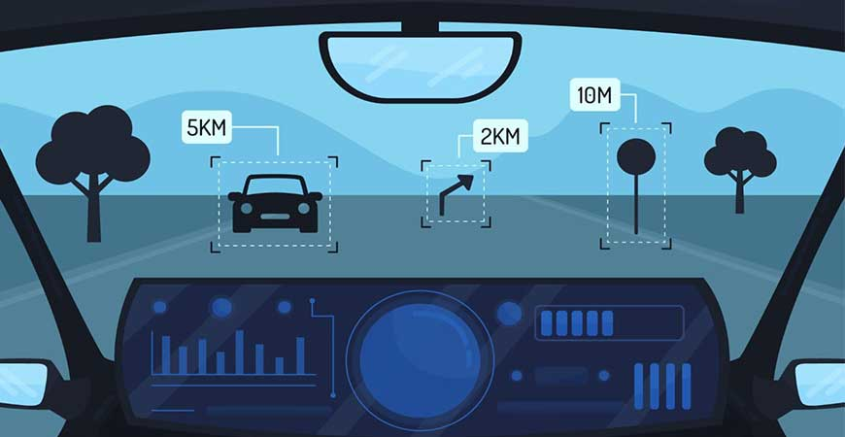

**Examples and Results**

There haven't been specific examples or publicized results of cloning the algorithm of a self-driving car for the stopping mechanism. Cloning the algorithm of a self-driving car is a complex and challenging task, often subject to legal and intellectual property considerations.

Companies like Waymo, Tesla, Cruise, and others have invested significant resources in developing proprietary self-driving algorithms that encompass various functionalities, including the stopping mechanism. Their algorithms are designed to ensure safe and efficient stopping, taking into account factors such as object detection, decision-making, and control.

**Conclusion**

Cloning the algorithm of a self-driving car specifically for the stopping mechanism involves replicating and adapting the relevant components responsible for object detection, decision-making, and control. While there are no widely documented instances of cloning algorithms for the stopping mechanism, significant progress has been made in the development of self-driving car technology overall.